ONTARIO POSTING REQUIREMENTS - ONTARIO POSTERS
To make sure workers know their rights, most workplaces in Ontario must put up posters and other information.

EMPLOYMENT STANDARDS ACT
All workplaces covered by the Ontario Employment Standards Act 2000 must distribute an employment standards poster to all employees. Employers are no longer required to post it in the workplace. This poster:

- describes important rights and requirements under the Employment Standards Act
- must be provided to employees who are covered by the ESA within 30 days of their date of hire
- is available in multiple languages upon request
- must be the most recent copy of the poster Please see Appendix A.

OCCUPATIONAL HEALTH AND SAFETY ACT
All workplaces covered by the Ontario Occupational Health and Safety Act must put up:

- “a health and safety at work“ poster
- a copy of the Occupational Health and Safety Act (providing such information about the Act and the regulations as the Employer considers appropriate)
- the names and locations of the workplace joint health and safety committee members, if any, or the health and safety representative (if applicable)

If the workplace has more than 5 regularly employed workers, the employer must also prepare, maintain and post the health and safety statement, workplace violence and workplace harassment policies - these must be dated and signed.

The Health and Safety at Work poster:

- outlines the rights and responsibilities of workers, supervisors and employers under the Occupational Health and Safety Act
- includes a Ministry of Labour, Immigration, Training and Skills Development telephone number (1-877-202-0008) to report critical injuries, fatalities and work refusals
- can be printed in colour or black and white
- must be displayed in English and the majority language of the workplace
- must be printed on paper that is at least 8.5 × 11 inches (letter size).

Please see Appendix B.

WORKPLACE SAFETY INSURANCE ACT
Workplaces covered by the Workplace Safety Insurance Act

Employers who are covered by the Workplace Safety and Insurance Board (WSIB) must put up:

- In case of injury poster This poster:
- is from the Workers Safety and Insurance Board (WSIB)
- outlines the steps workers and employers need to take if there is an injury at work
- must be displayed prominently in the workplace and at each first aid station, if any Please see Appendix C:

ADDITIONAL POSTING REQUIREMENTS
- The “In Case of Injury” Poster (Form 82) at a first aid station and in other conspicuous place
- A copy of the Occupational Health and Safety Act and any explanatory material prepared by the Ministry, such as: "Health & Safety at Work: Prevention Starts Here” Poster
- The occupational health and safety policy
- Accurate records of the levels of biological, chemical or physical agents in the workplace (OHS Act, Sec. 26(1)(f))
- Names and work locations of the joint health and safety committee (JHSC) members, if any (OHS Act, Sec. 9(32)) or the health and safety representative (if applicable)
- JHSC meeting minutes and inspections must be posted on a health and safety board (H&S board), if applicable
- If first aid trainers are required at the workplace, their names must be posted on a health and safety board
- Annual Workplace Safety and Insurance Board (WSIB) summary, if requested from WSIB (OHS Act, Sec. 12(2))
- The workplace violence and workplace harassment policies (not required for 5 or fewer employees) (OHS Act, Sec. 32.0.1 (2))
- Any order regarding the use of biological, chemical or physical agents in the workplace (OHS Act, Sec. 33(3) and 41(3))
- Any Ministry of Labour order (OHS Act, Sec. 57(10)(a))
- A notice of compliance with an order (OHS Act, Sec. 59(3))
- Results of monitoring of airborne concentrations of a designated substance and worker exposure to airborne concentrations of a designated substance (Designated Substances Regulation, Sec. 25(a))
- Safety Data Sheets must be posted in a binder and/or near the H&S board, if any
- Emergency phone numbers and the emergency evacuation plan must be posted on the H&S board
- Accessibility Policy (AODA) and additional AODA postings depending on employer size

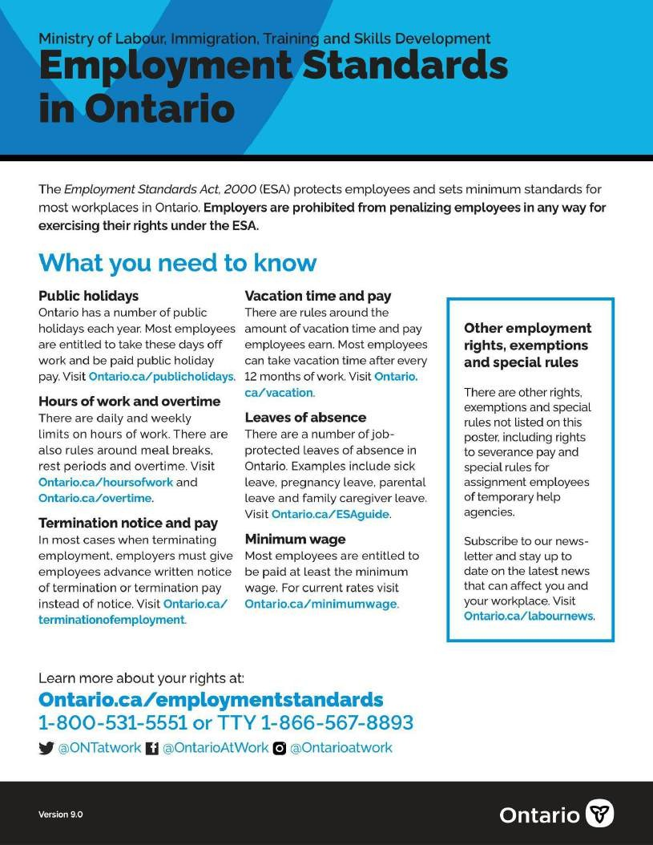
APPENDIX A:

APPENDIX B:

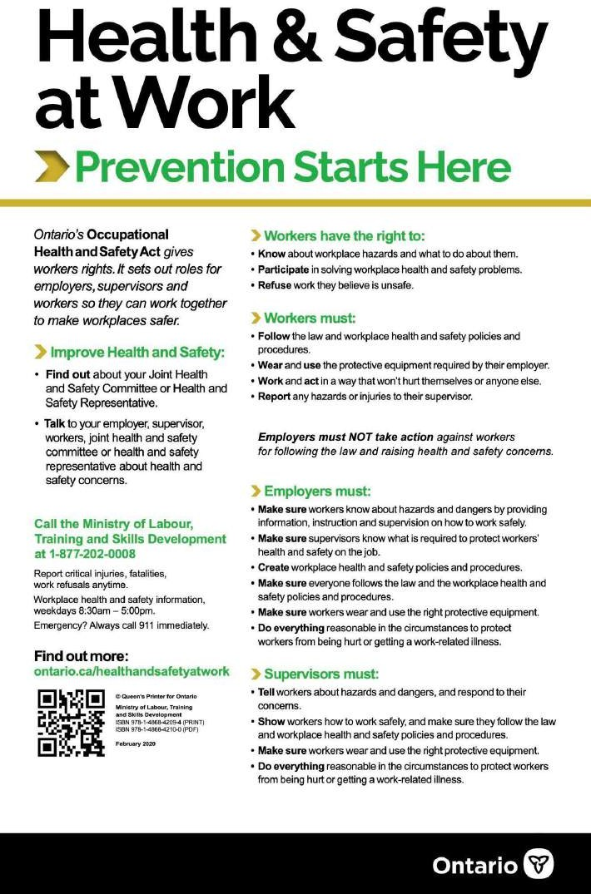

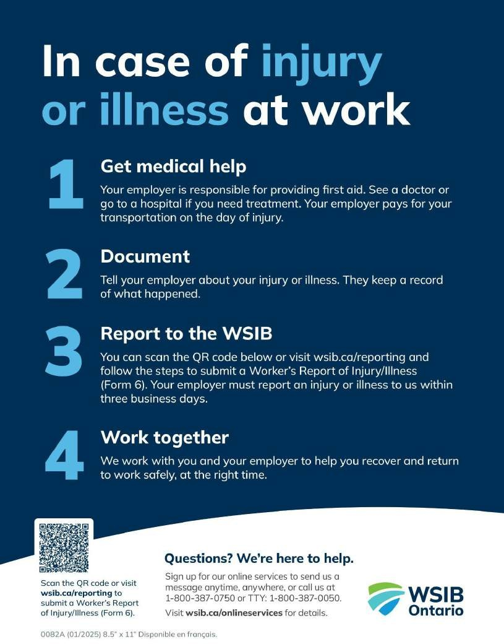
APPENDIX C:

